1.1 Place the optical breadboard on top of the airtable. In doing so, make sure that your surgical microscope, as well as, yourself can easily access all of the board.

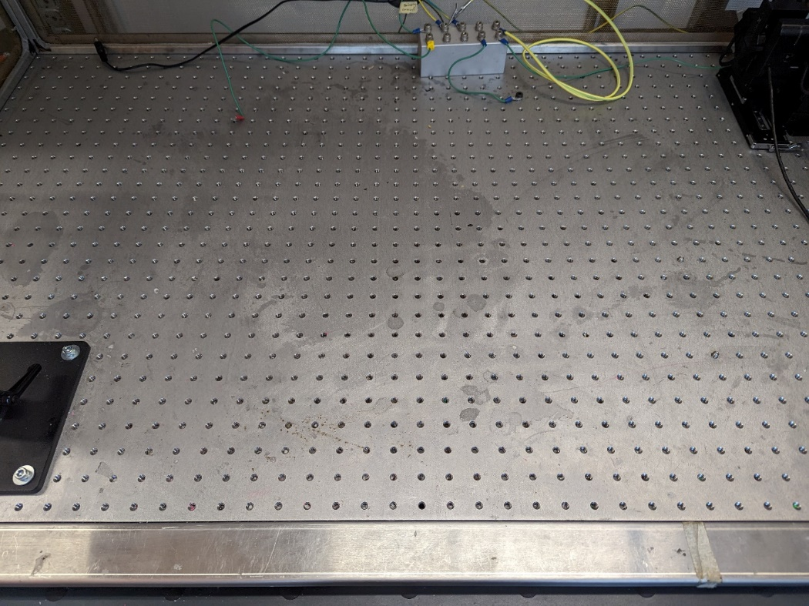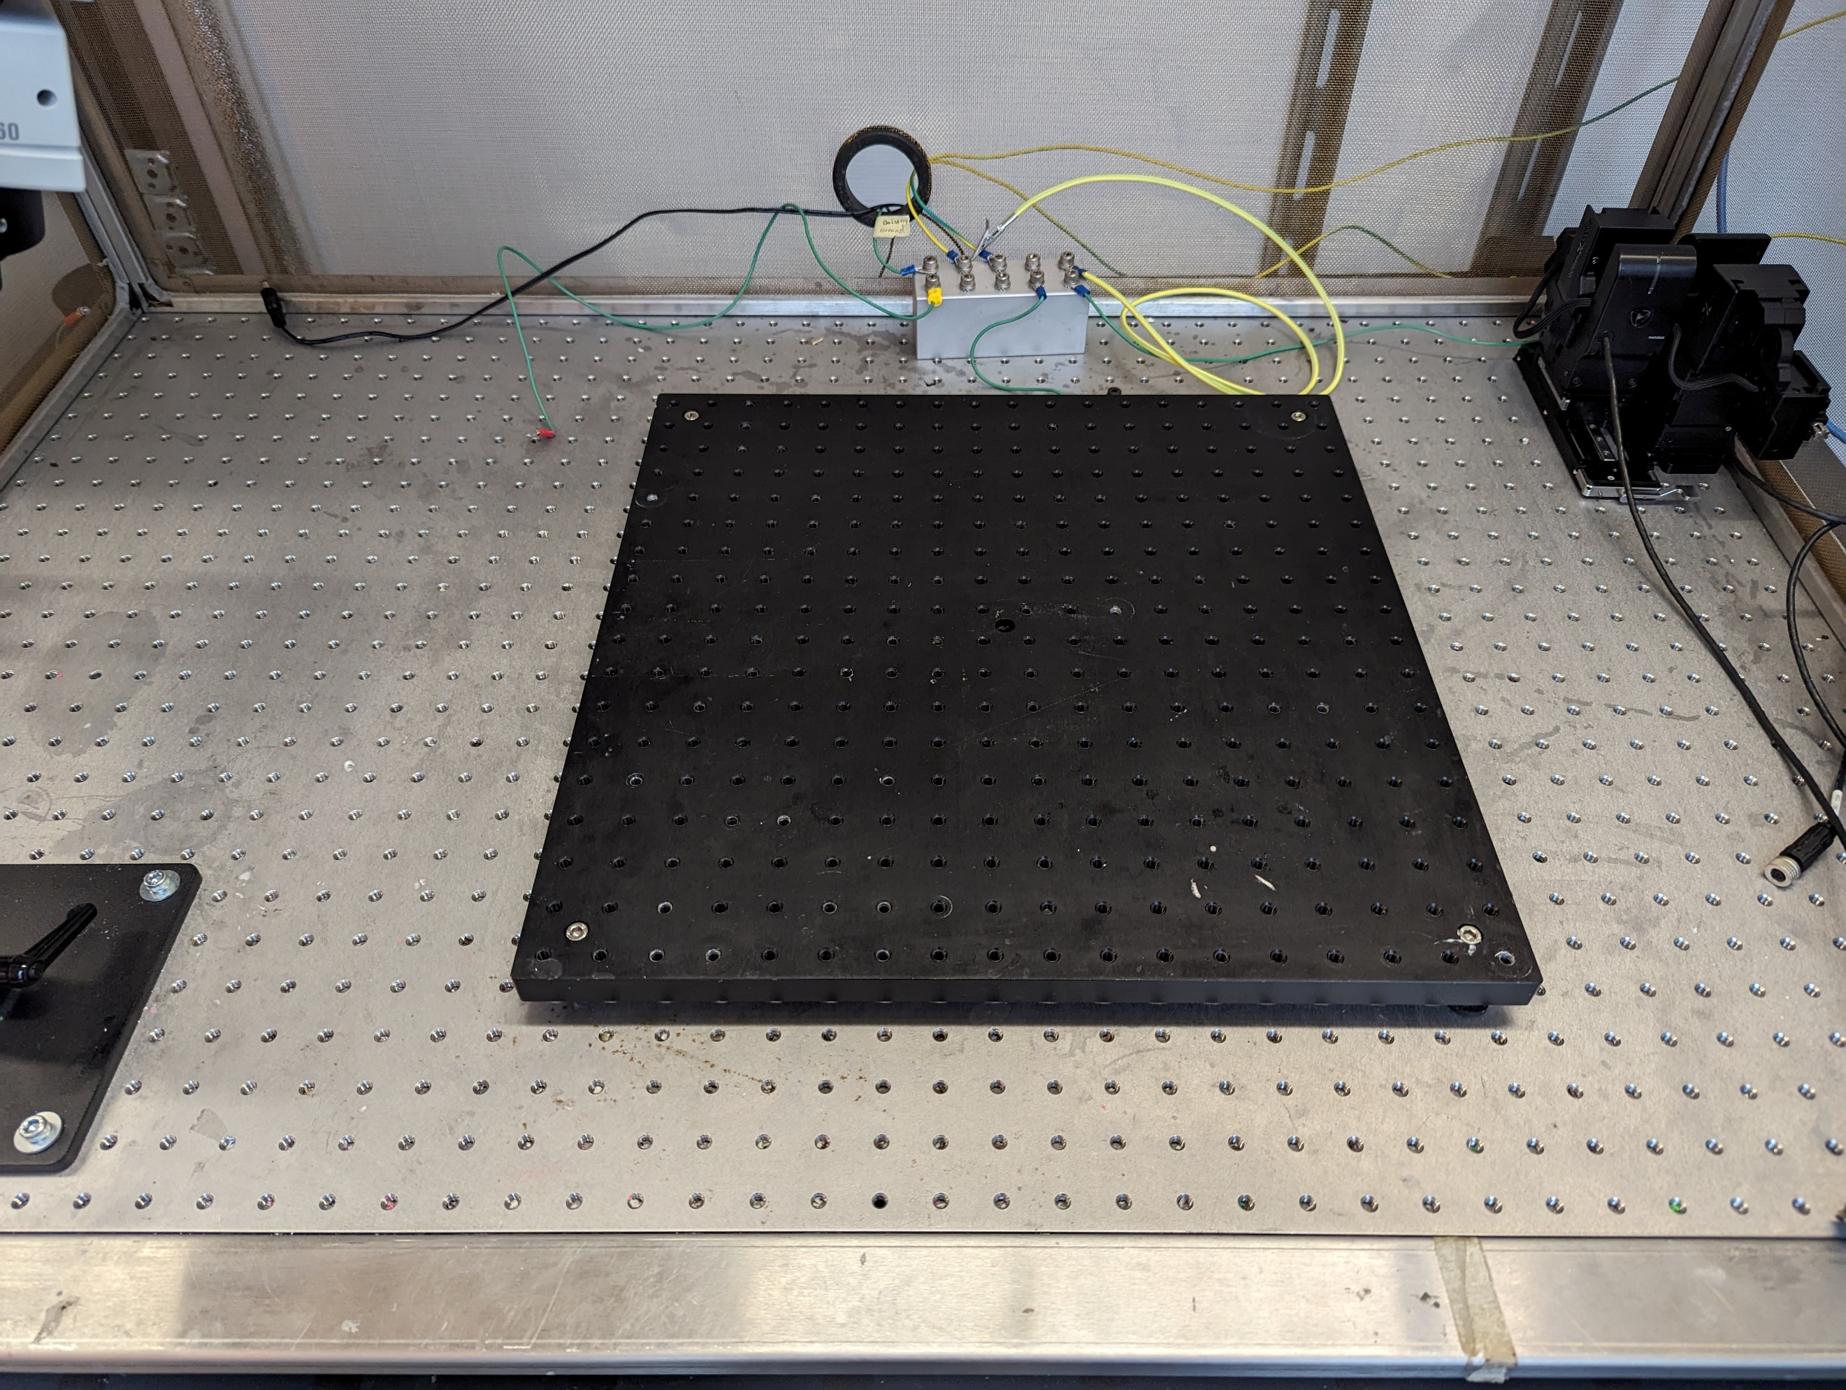

Range of scope

1.2 Screw a 2cm M6 or x imperial bolt into the thorlabs rod (if it doesn’t have one already).   
1.3 Attach the 6cm long thorlabs rod into the optical breadboard. Make sure that your micromanipulator will be placed close enough that it can reach most of the breadboard. For us we place the rod x cm from the center.   
1.4 Fasten the rails of the micromanipulator to the rod using a ring and an other 2cm 6M or x imperial bolt.   
1.5 Use the SensaPex grounding site to ground the micromanipulator by utilizing the tiny screw to fasten a grounding wire with a ring connector.

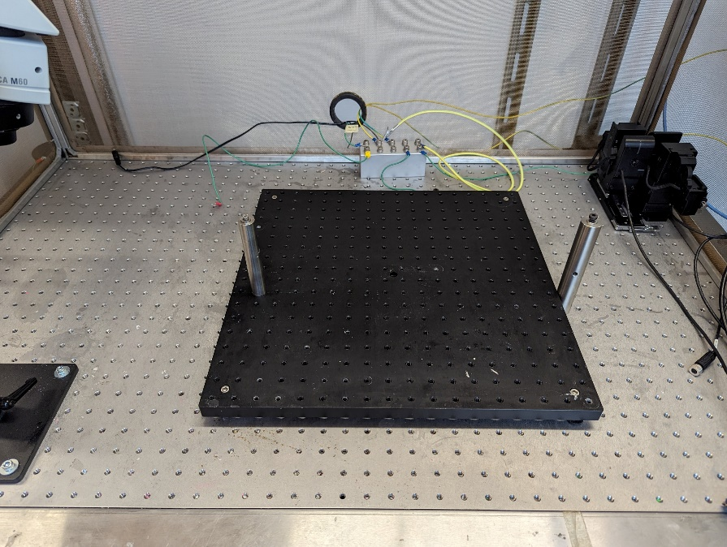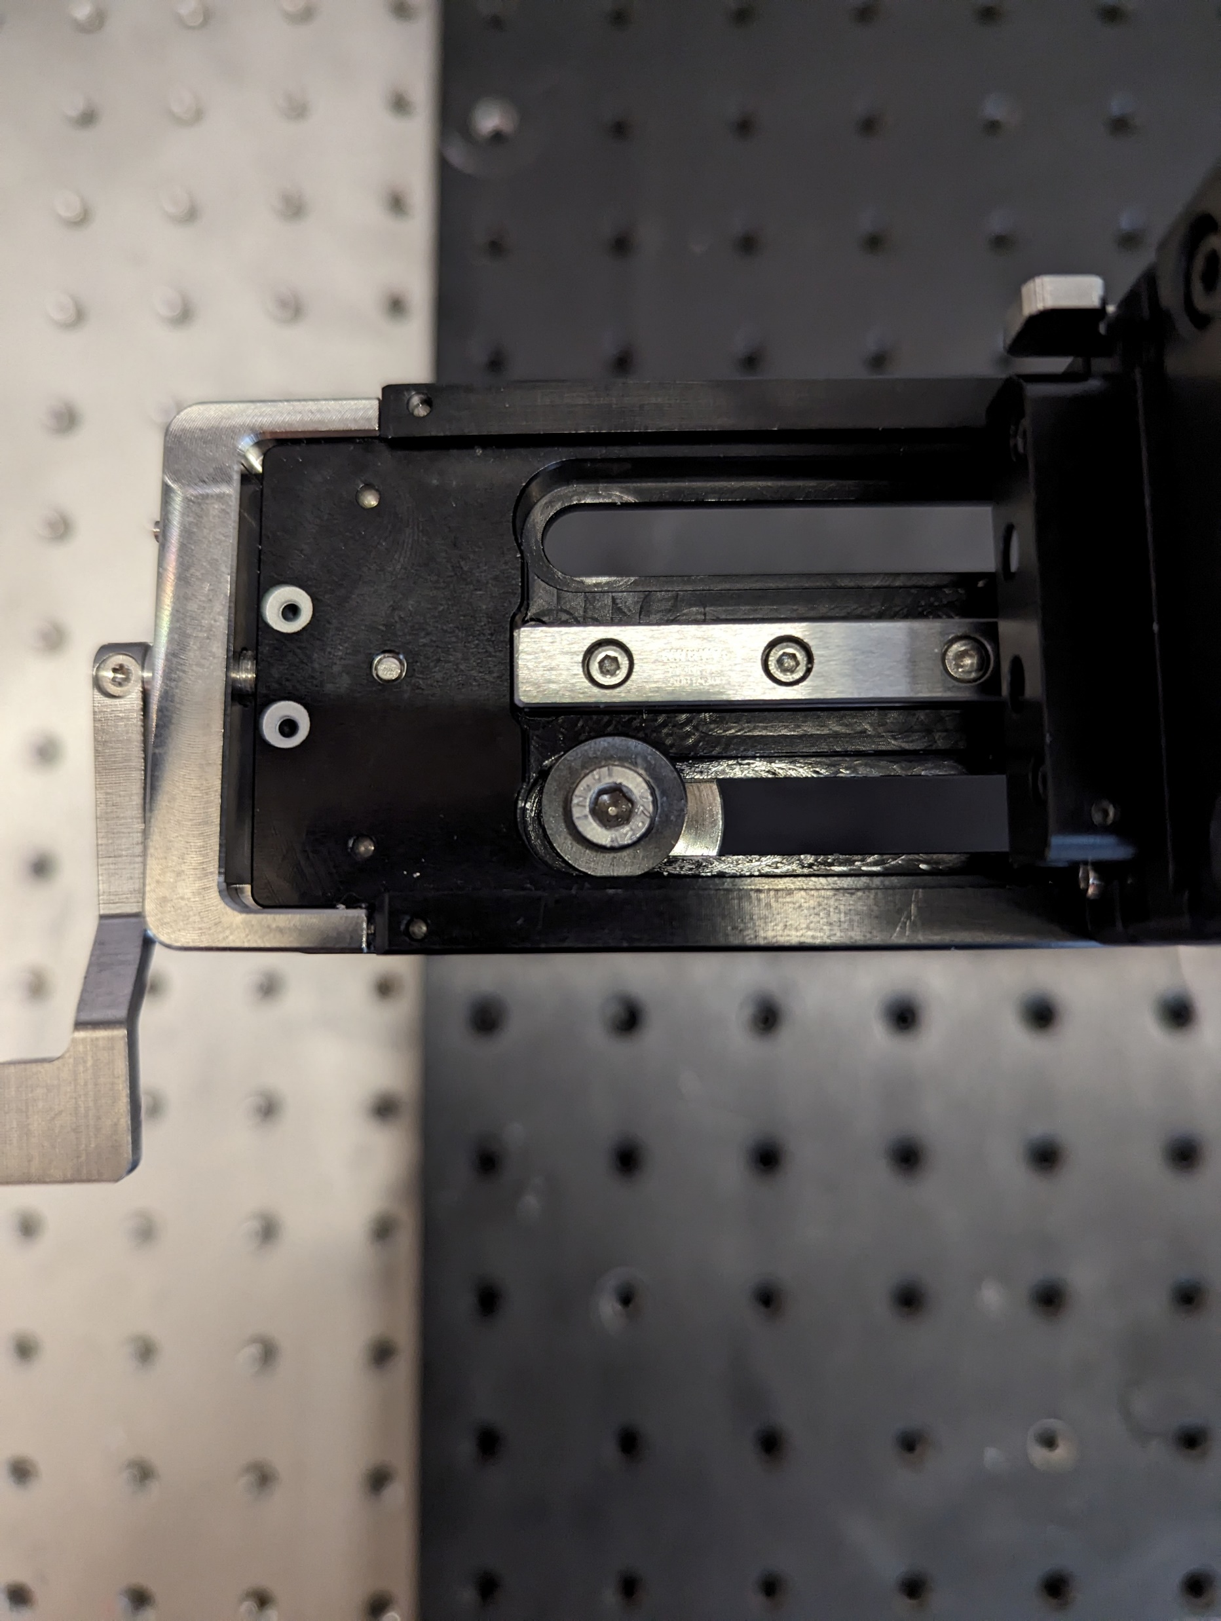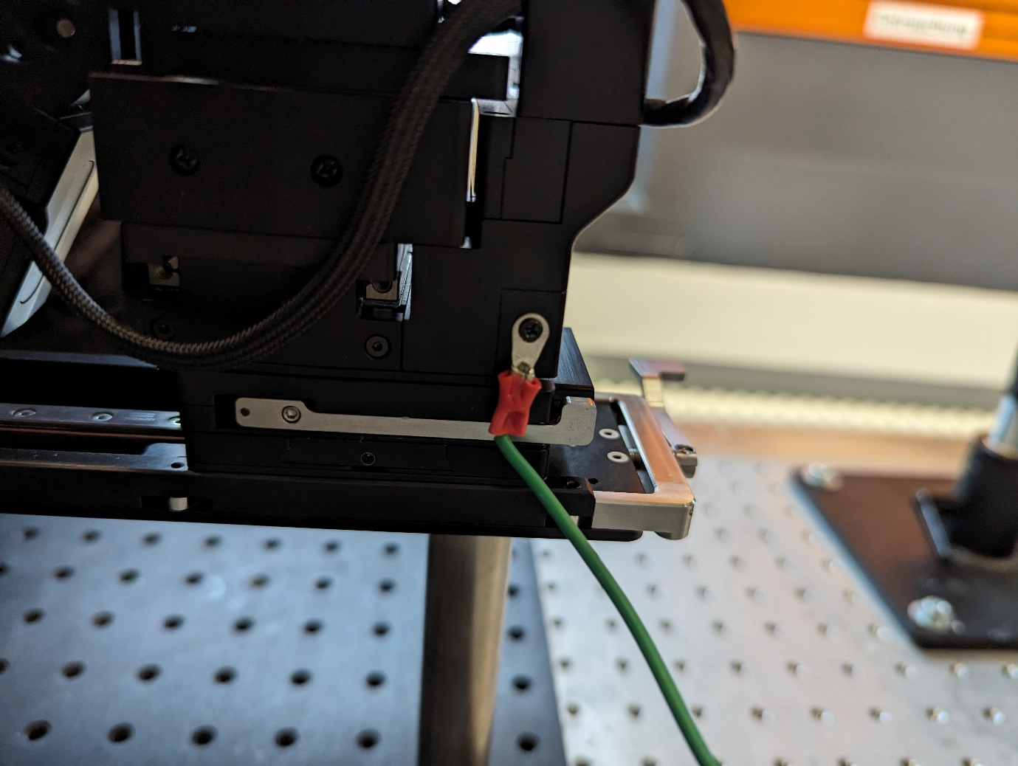

# Animal restraint

2.1 Place the animal restraint baseplate in the middle of the optical breadboard and secure its placement using two 2cm 6m screws.   
2.2 Place the special thorlabs rod with a xM screw to the AR baseplate.  
2.3 Horizontally fix a x cm x diameter rod to the vertical rod using a 90degree rod connector.

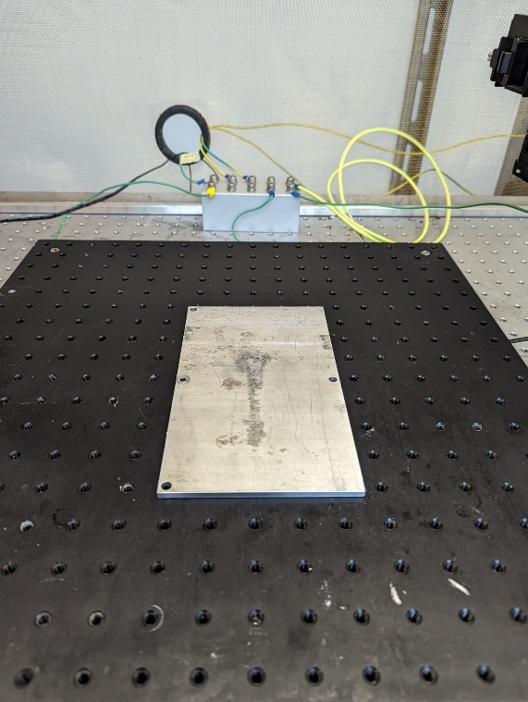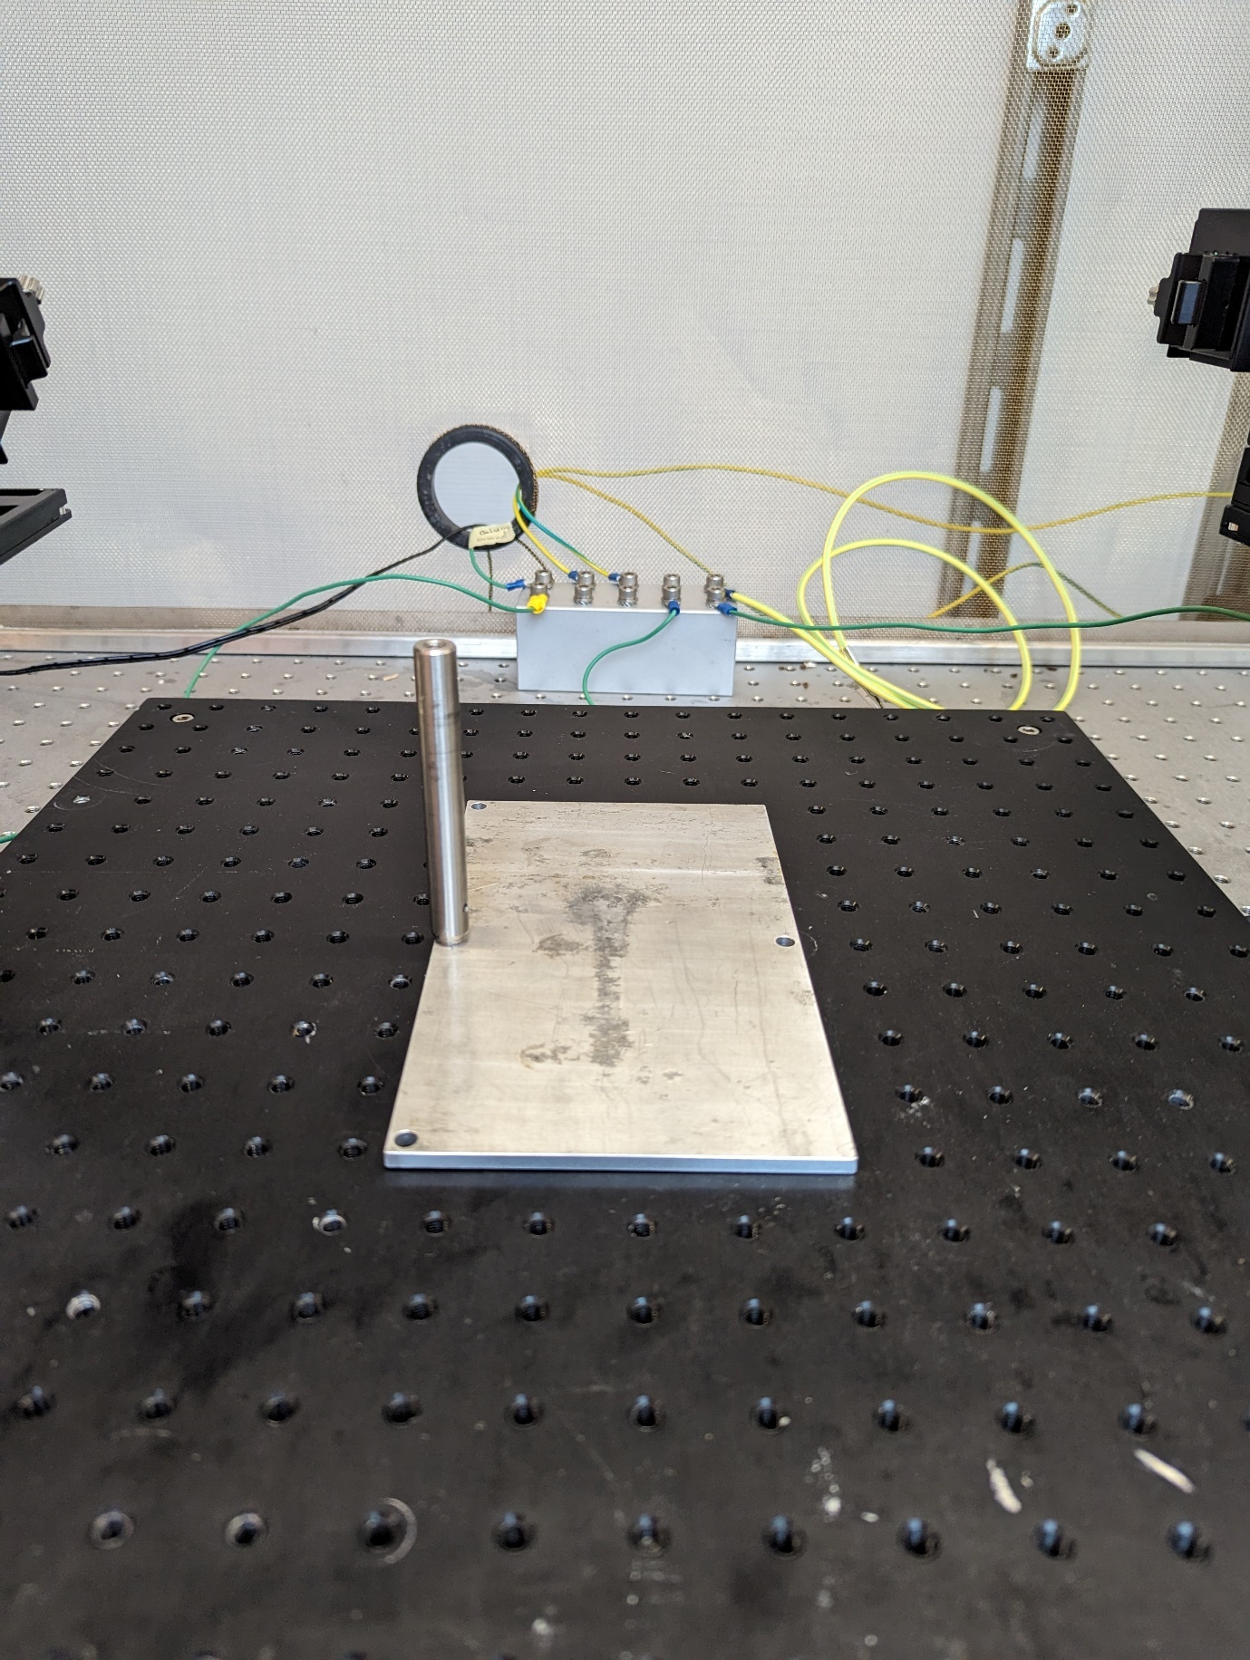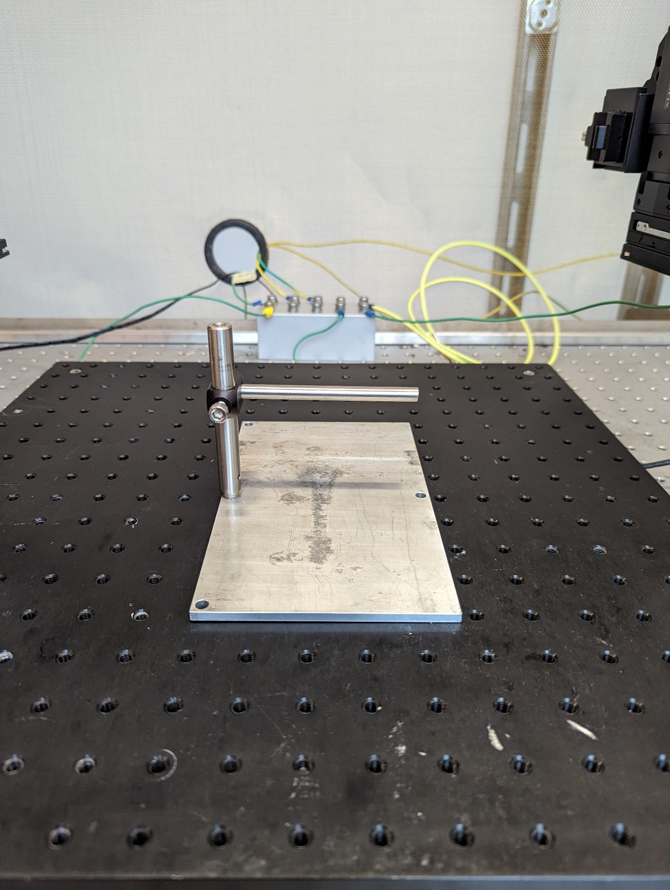

2.4 Connect the rod with the attached headbar holder. One can choose to wrap the connecting point with Kapton tape to minimize electrical noise from the animal through the headbar to the rest of the setup.   
2.5 Place the plastic tube directly underneath the headbar holder. Make sure that the holder has the correct height from the AR baseplate. Note that if you notice your animal being too pressed or lifted by the height of the holder that you should adjust the placement.   
2.6 Finally you should be able to place have the micromanipulator directly above the headbar holder.

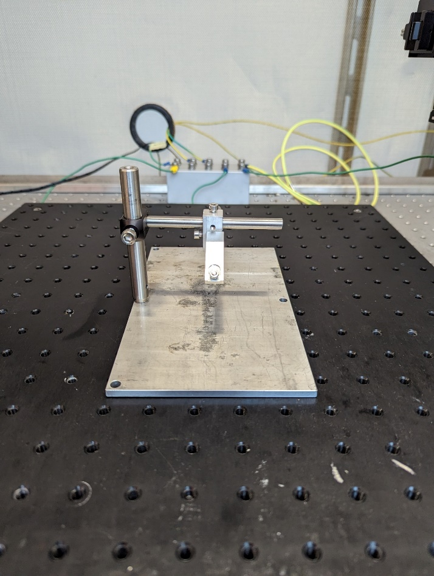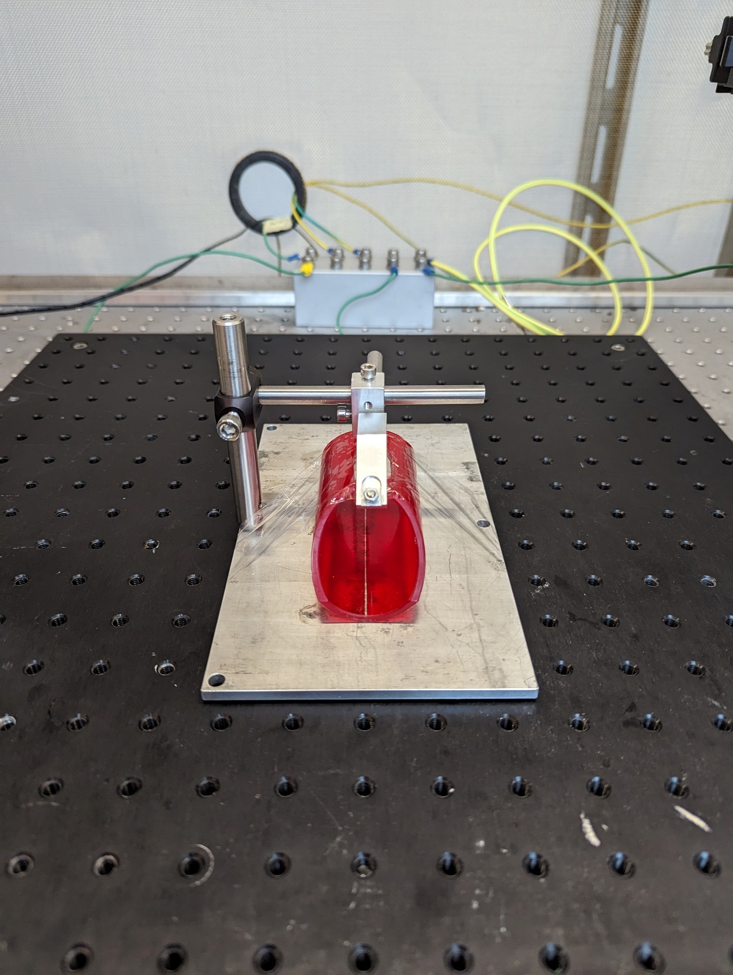

# Water reward

3.1 Position lick detector holder so that it can easily reach the animal restraint compartment. The holder should be flexible enough to reposition easily so that the animal can easily reach and the licking spout.   
3.2 Fasten the holder to the optical breadboard. We use a Thorlabs circle holder and screw this into the breadboard using two 2cm 6M screws. This then clamps the flexible holder to the optical breadboard.

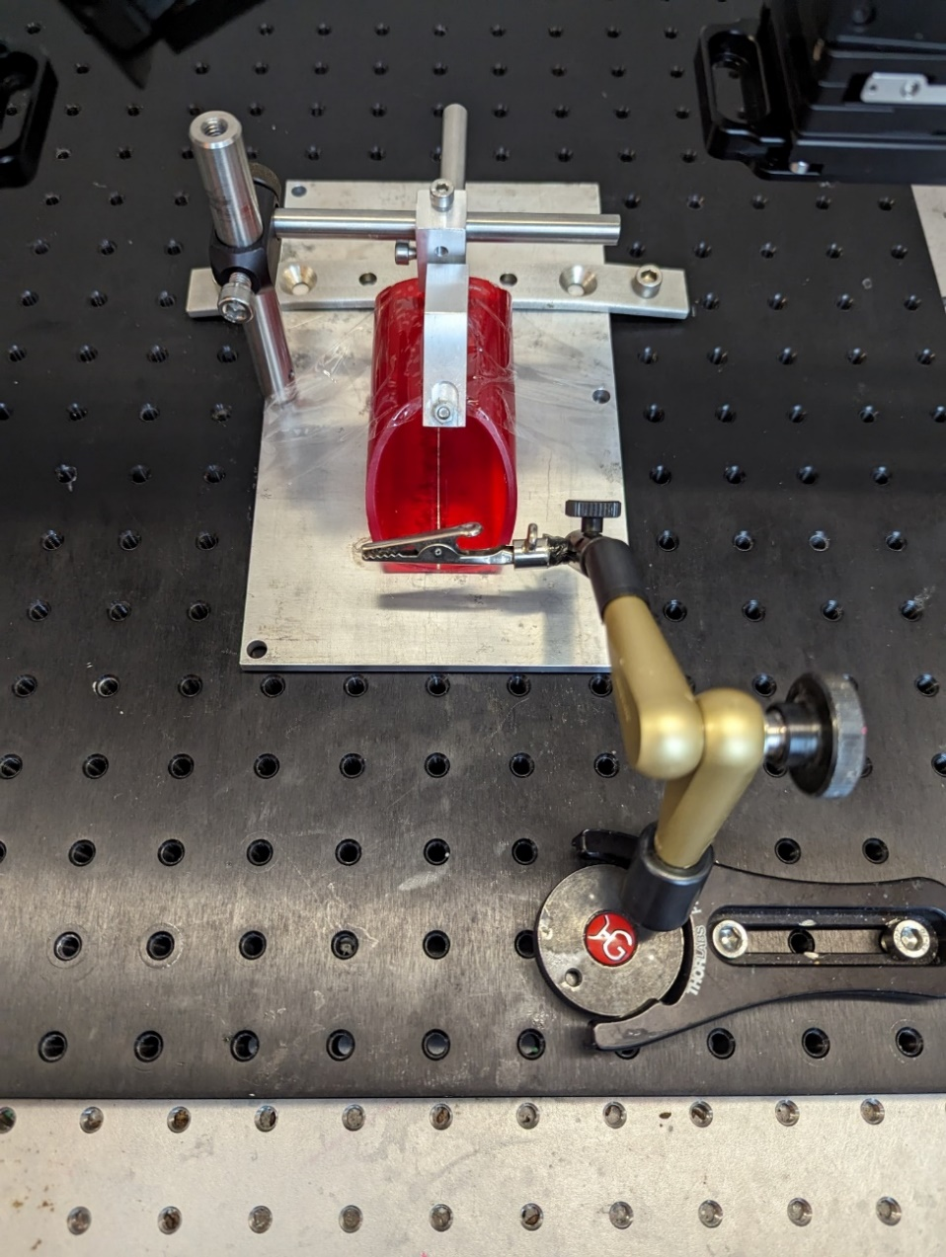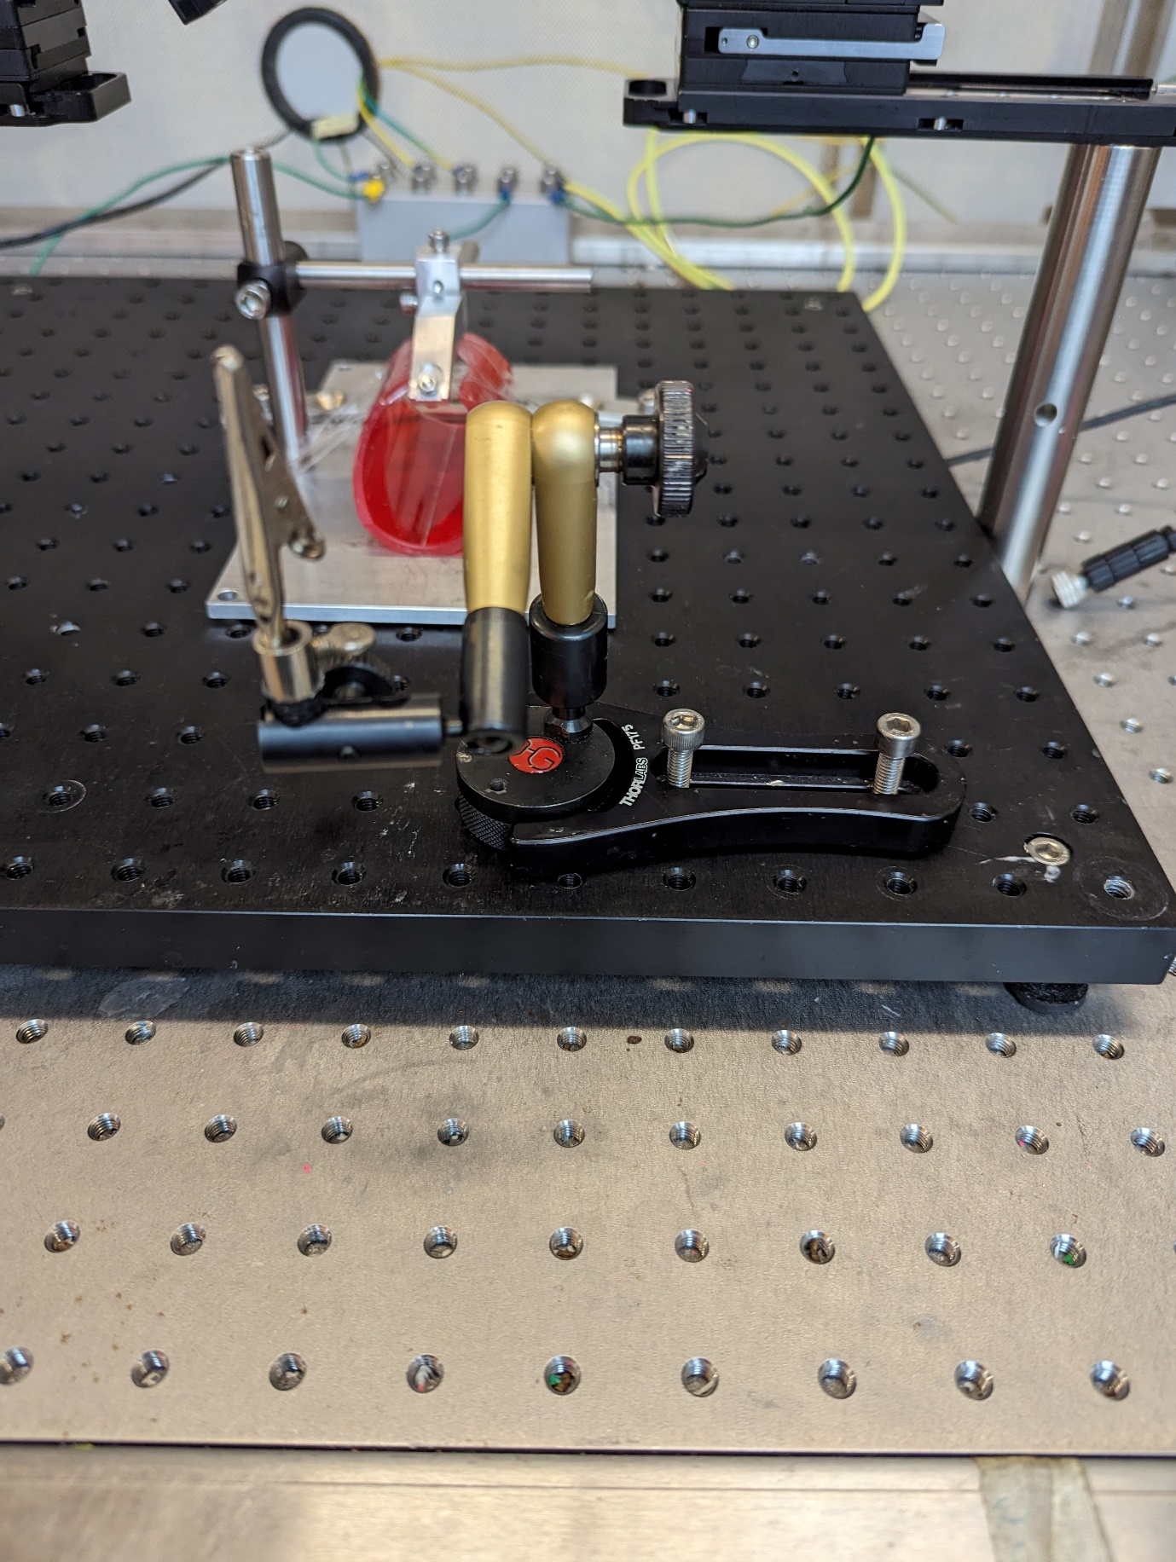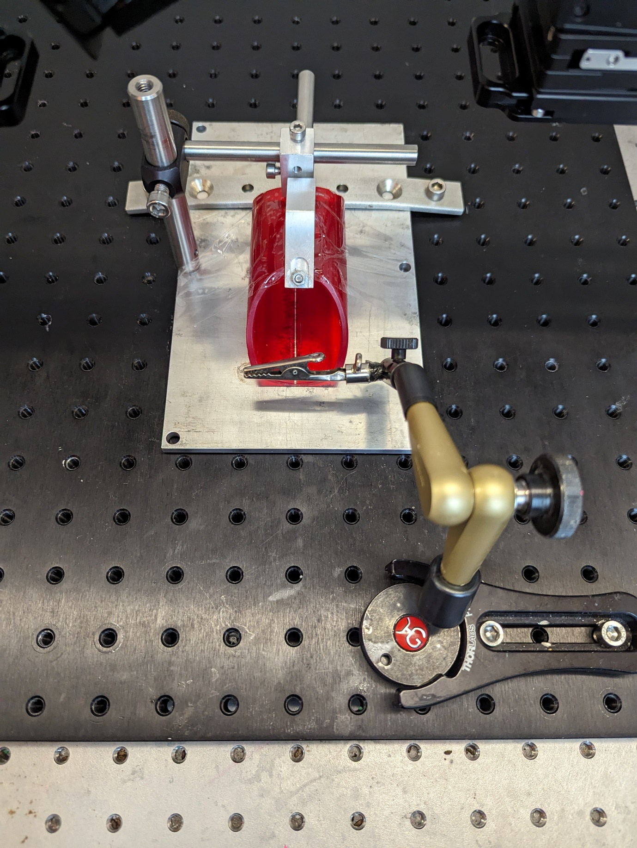

Range

3.3 Clamp the piezo sensor into the lick detector holder.   
3.4. Insert a blunt needle, we use a cut off x gauge syringe into the hole in the piezo sensor.  
3.5 Position the water reservoir on an elevated position nearby the setup. Be careful around your equipment. It happens that when applying pressure on the water reservoir the tubing shoots off and this can lead to damage.   
3.6 Connect the licking spout to the water reservoir with adequate tubing. We are using x ID tubing that is connected with a x connector from y.   
3.7 Lastly, clamp the tubing with the solenoid, note that the solenoid can get hot during use.

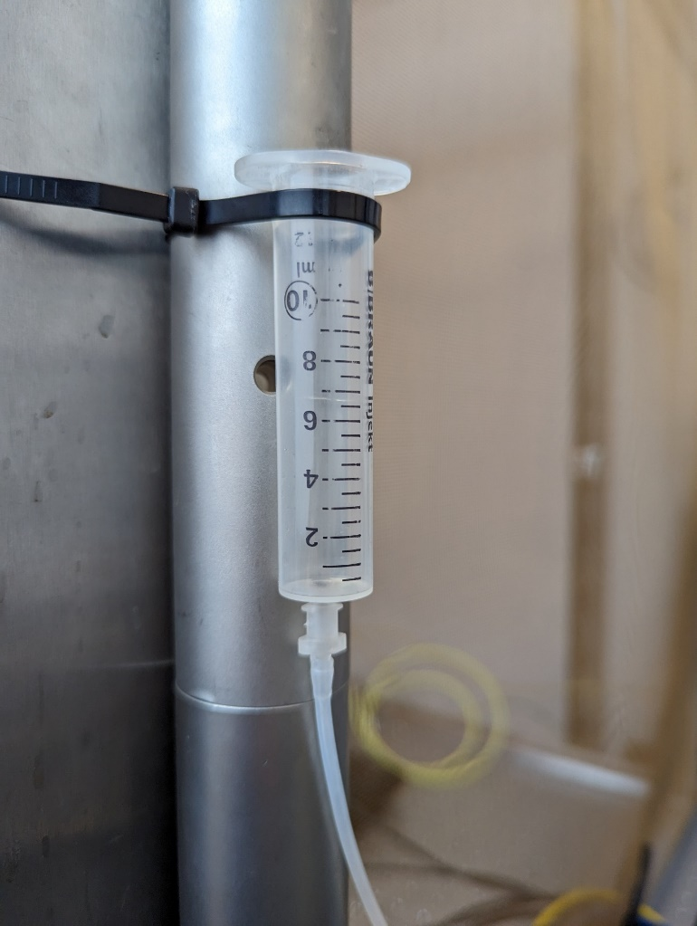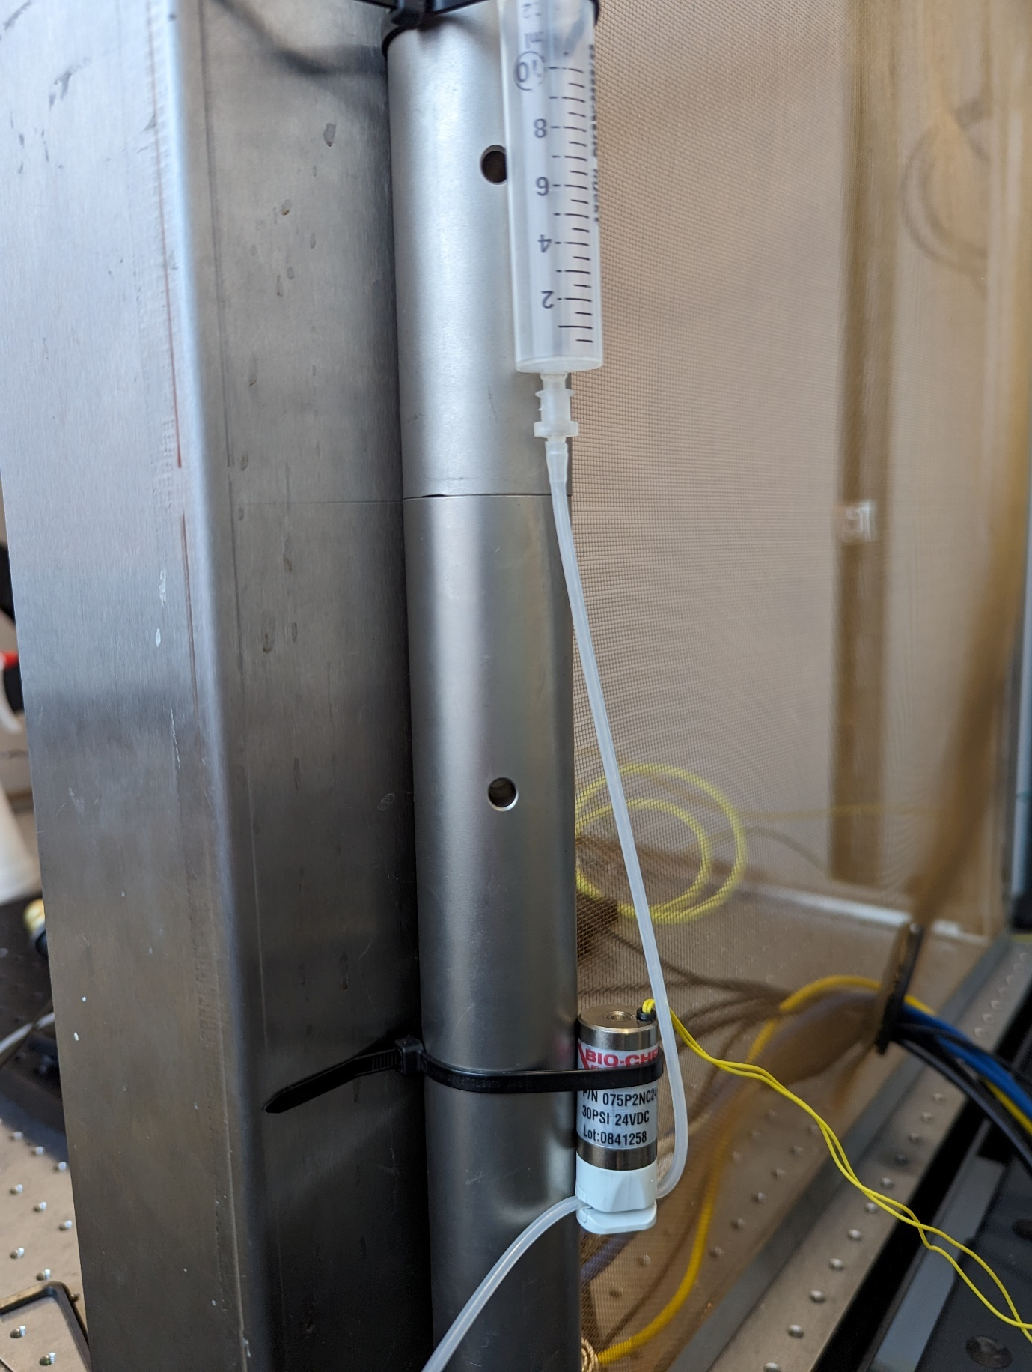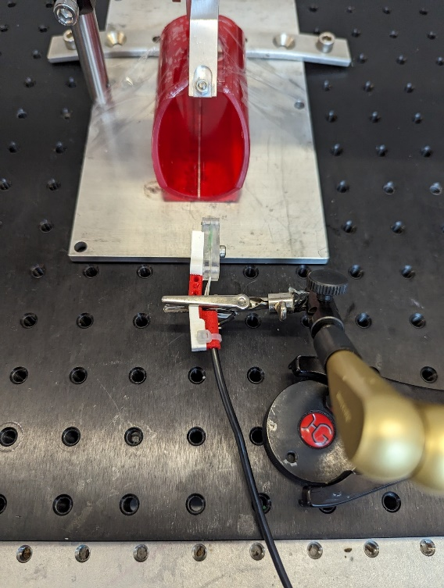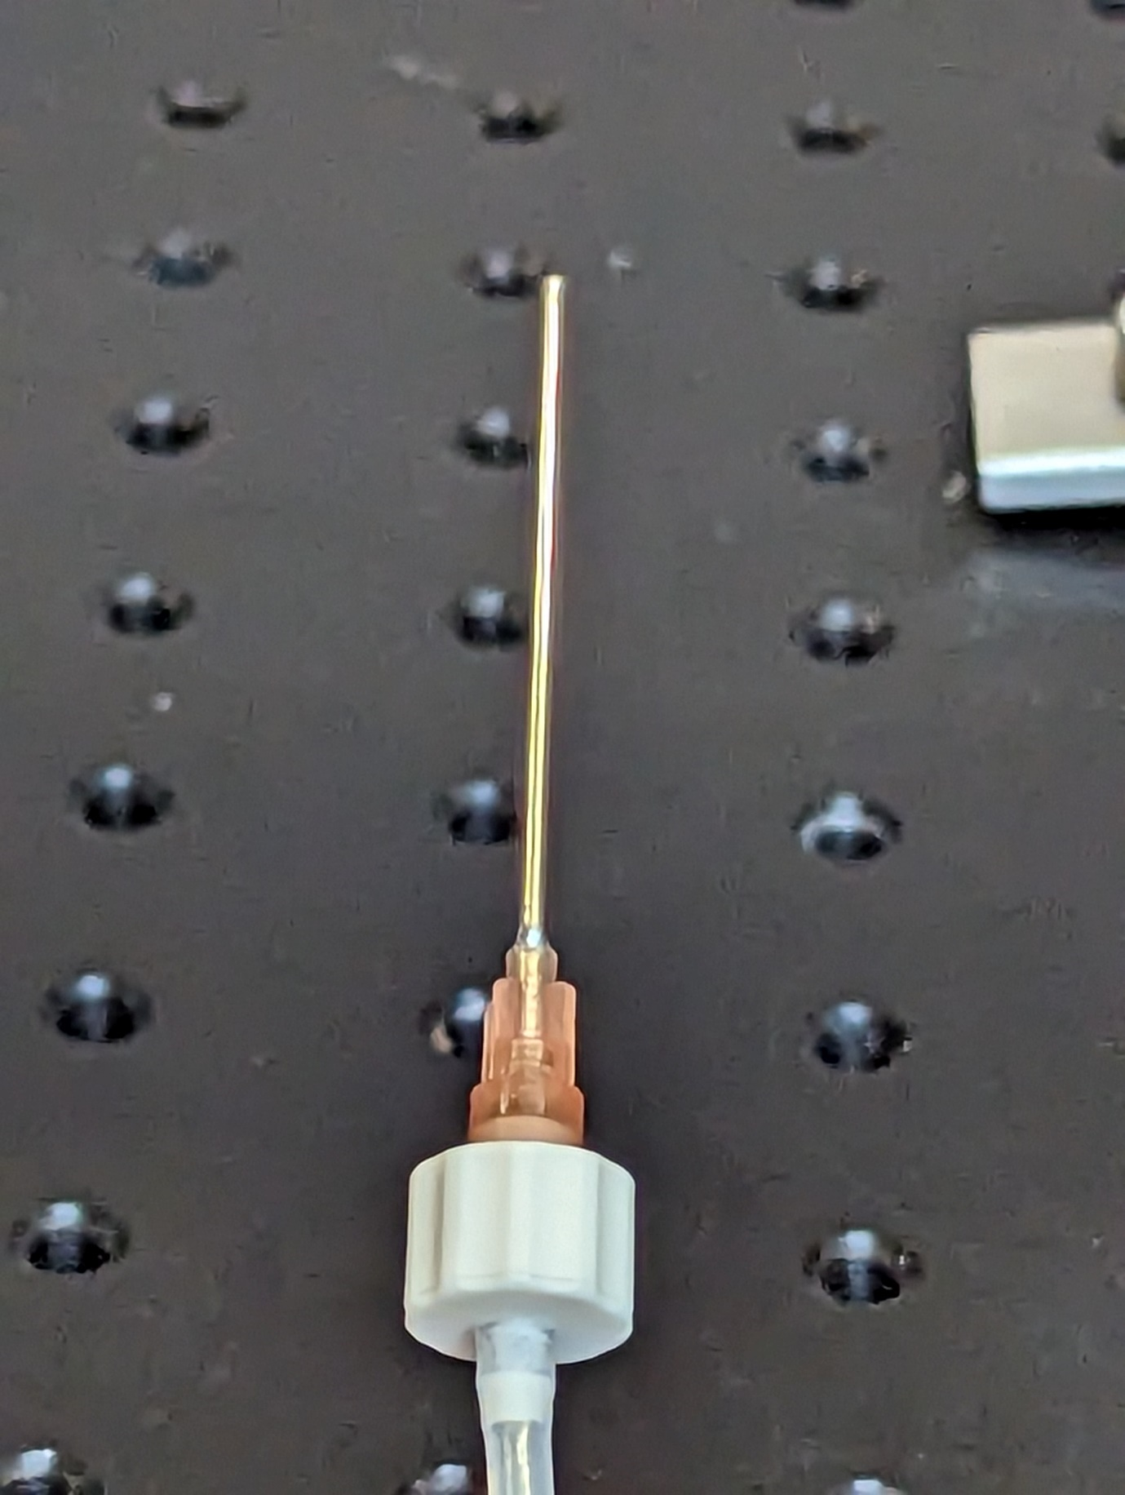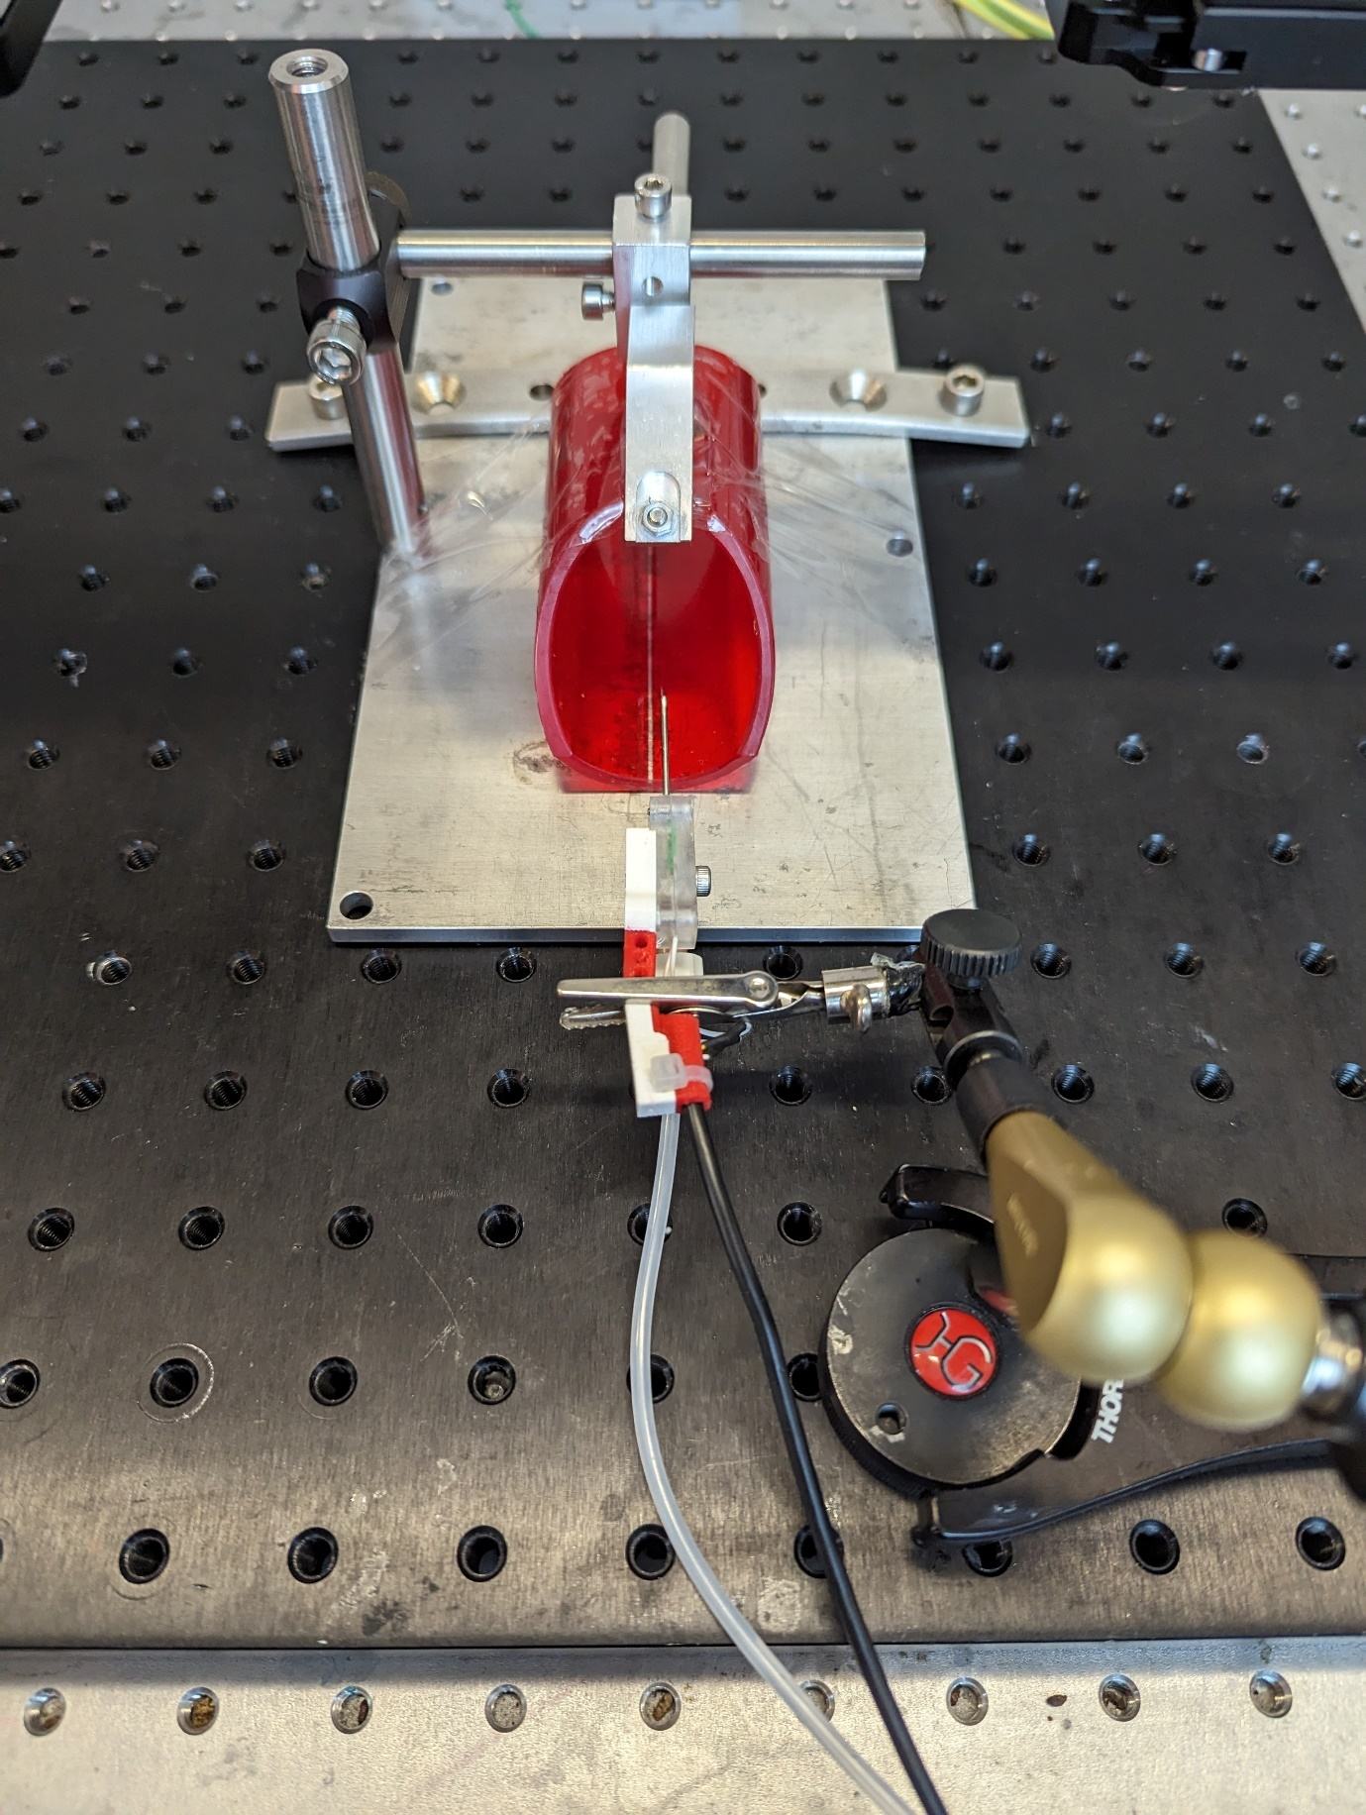

# Stimulation

4.1 Wire up the Arduino due and Uno according to the wiring diagram provided.  
4.2 Use a serial/ethernet cable to connect BPOD behavioural port x with the BPOD shield on the Arduino DUE.   
4.3 Use a +- to BNC cable to connect the Arduino uno pin 8 and ground to the Stimulus isolator INPUT  
4.4 Plug in the + and _ wire and place them in the setup. You will only need to connect these wires when doing experiments to the + and – of the electrode   
4.5 Set the correct amplitude on the stimulus isolator be putting the dial to x and the percentile to y.

# Video recording